SIA "GRAVITIS ENTERPRISE LIMITED"
Lauku iela 7 - 4, Cēsis, LV-4101, Latvia

Technical Drawing Package

Solar Eclipse Plastic Glasses (EGP-FIT-TDP)
Document Title: | Technical Drawing Package
Product | Solar eclipse glassses. Model: EGP-FIT-TDP
Document No.: | EGP-FIT-TDP-001
Revision: | A
Date: | 5/2/2026
Status: | FOR NOTIFIED BODY SUBMISSION

 |   Name | Signature | Date
Drawn By: | Māris Grāvītis |  | 13/3/2026
Checked By: | Māris Grāvītis |  | 13/3/2026
Approved By: | Māris Grāvītis |  | 13/3/2026

Table of Contents
Revision History 2
Fabrication Specification (EGP-FIT-FAB-001) 3
SPECIFICATION DATA 3
MANUFACTURING & QUALITY NOTES 4

Revision History

Revision | Description Of Changes | Date | Approved By
A | Initial Release | 05/02/2026 | Māris Grāvītis

Fabrication Specification (EGP-FIT-FAB-001)
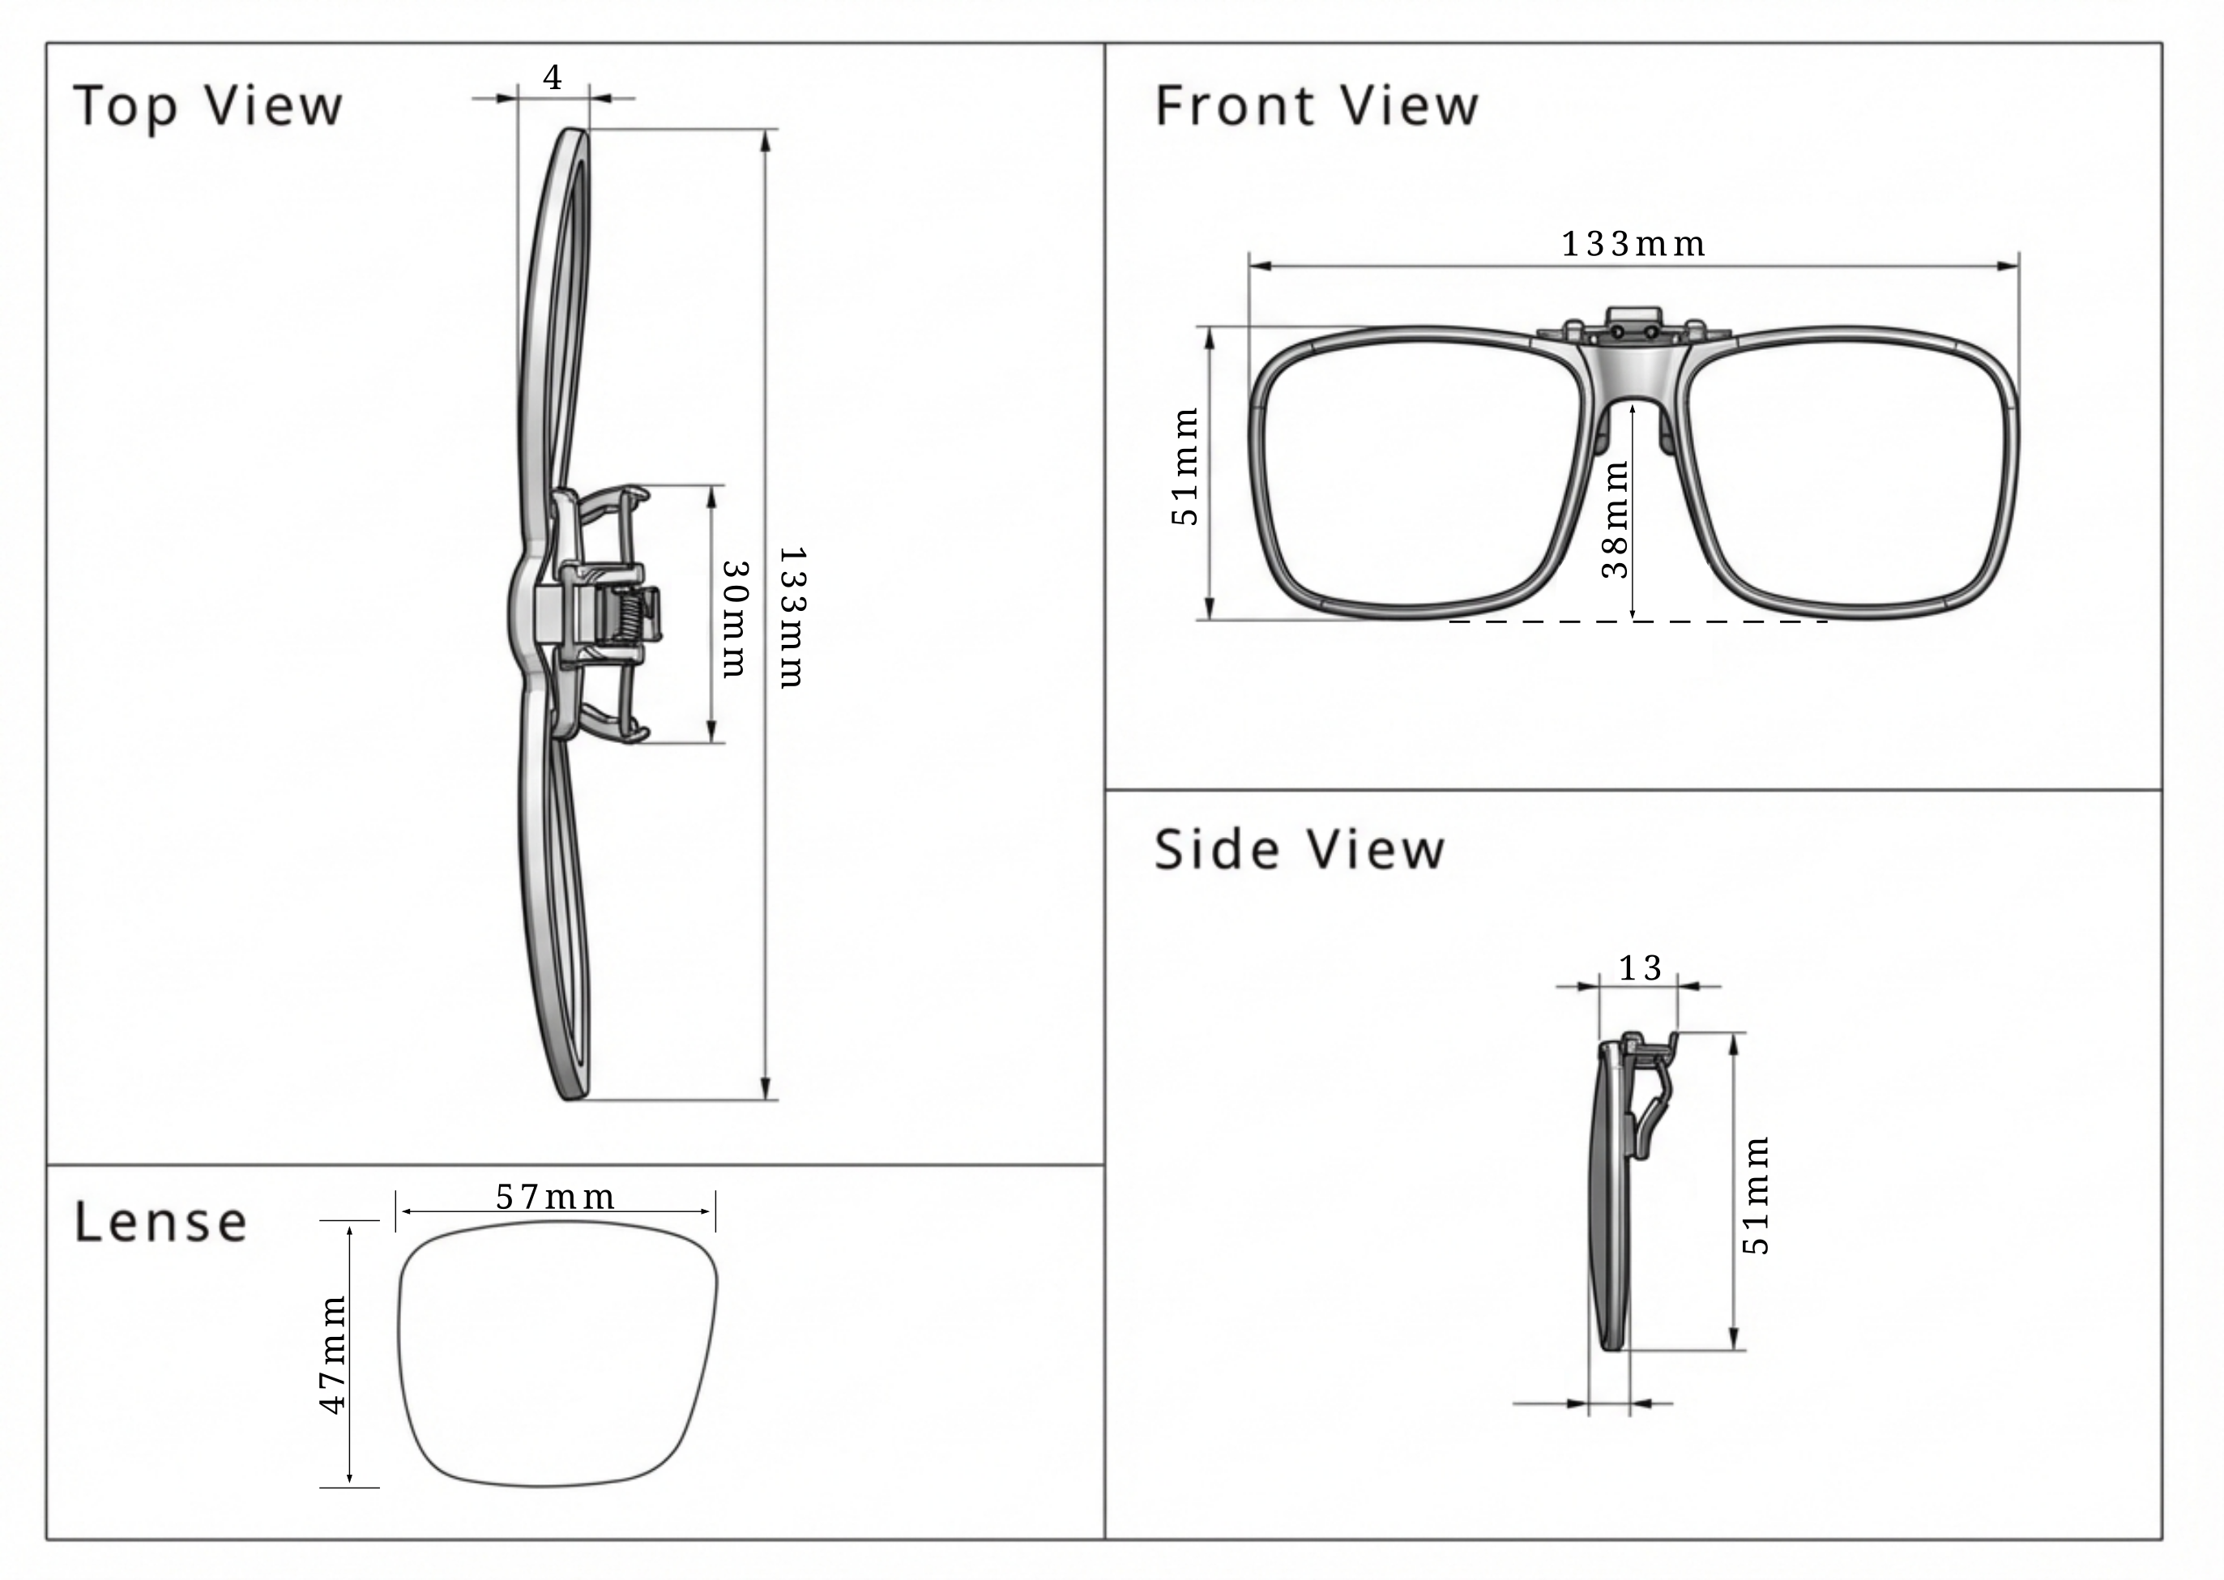

Specification Data
Parameter | Specification
Product Model | EGP-CLP (Solar Clip-On)
Standard | EN ISO 12312-2:2015 (PPE Category II)
Filter Material | Silver-Black Polymer (0.12mm nominal)
Mechanism | Spring-loaded Bridge with Flip-Up Hinge
Hardware Material | Alloy Spring / ABS Plastic Clamp / Soft Rubber Tips
Optical Density | OD ≥ 5.0 (Transmittance ≤ 0.0032%)
Weight | ~18g (Nominal)

MANUFACTURING & QUALITY NOTES
1. MECHANICAL SAFETY & INTEGRITY:
- Clip Tension: The spring mechanism must provide sufficient tension to securely grip standard prescription frames without slipping, but must not be so tight as to damage the user's eyewear.
- Hinge Friction: The flip-up hinge must hold position. It must not fall down (blocking vision unexpectedly) or flop up (exposing eyes to sun) under normal head movement.
- Protective Tips: The clamp arms must be capped with soft non-marring material (Rubber/Silicone) to prevent scratching the user's prescription lenses.
2. OPTICAL SAFETY:
- Filter Quality: Filter surface must be free from pinholes, scratches, or delamination.
- Coverage: When clipped to standard frames, the filter must fully cover the optical zone of the underlying lenses.
3. MARKING & TRACEABILITY:
- Exemption from Direct Marking: Due to the wire-frame construction and lack of viable surface area (>5mm) on the clip mechanism, no regulatory markings are applied to the product.
- Compliance: All mandatory markings (CE, Notified Body 0068, ISO 12312-2, Manufacturer Address) are applied to the Primary Packaging and Instructions for Use. (See Document: PKG-EGP-CLP-001).

